Ericka Najera

Karla Chavez

Quiz 7

The process to making the threads work, we initially typed in the code Dr. Mejia provided us. Although we had an issue with making it work we learned that the Thread takes in two parameters which are the name and the thread. We created a third thread to satisfy the requirement from the example output. From there we knew we needed to print the current time for each thread so instead of counting up to 10 we simply printed the local time using java.time.LocalTime(). From there I saw while researching on threads that you can out the thread to sleep for a certain time in nano seconds. In this case we used Thread.sleep(5000) which is equivalent to 5 seconds. Since it was synchronized, at first each thread would print the same time and and then after 5 seconds they would exit. Then we created a for loop of 3 and it did the same thing three times all the thread printing the same time.

Then I realized about the flow chart about the notify and wait methods that the thread included and I decided to research about it. So inside the synchronized method we placed a thread.wait(). After it ran the threads were printing the current time 5 seconds apart but when they reached the wait, the program never ended. We were having trouble trying to find a way to place the notify all in the correct spot since it needed to be inside a synchronized thing.

We decided to place a synchronized in the actual time method and place a notify after it prints the time. Magically it worked but somehow the threads didn’t appear a 1,2,3 order but a weird order like 1,3,2,2,3,1,3.

Then we realized that what we need to do was start the thread 3 times since when you create it, it will not be null anymore. This avoids the need to have a notify all and wait. The start method we changed the start to have an else statement, if the thread was already created then we place a run() instead. We also replaced the join since it was joining at whatever order.

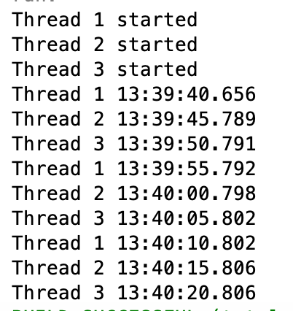

https://javarevisited.blogspot.com/2011/05/wait-notify-and-notifyall-in-java.html